Through our irresistible way of learning, children can understand the works of art produced by a wide range of masters and modern artists to influence their own work.

After school art club is available to all year groups which involves improving drawing skills, painting techniques and the opportunity to work on large scale outdoor art pieces including local art-based competitions.

We are artists: children are ‘hooked’ from the beginning of lessons and allowed time to play and explore.

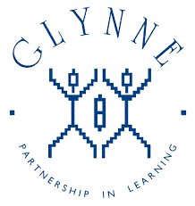

Art is used in mindfulness sessions and to express emotions or responses to music.

Knowledge and skill grid in place for art to ensure progression across phases.

Each term, whole school assessments are completed by EYFS to year 6 to gain an overall picture of the progression of skills and create our own exemplification of standards.

Children are encouraged to share their artistic talents during our Midsummer Madness arts festival.

Annual action plans are completed and reviewed by subject leads, with these being shared with Governors.

Whole school arts focus week is centred on either famous artist, artistic movements, or a focus text.

The national curriculum programme of study for art is enhanced by own school curriculum.

Monitoring includes book trawls and tea parties, with timely feedback being delivered to staff.

Creative and artistic displays in both classrooms and foyer areas for each year group showcase 2D work and 3D sculpture.

Whole school art opportunities are offered to improve and enhance the school grounds.

Children use sketchbooks, art folders and learning journeys as a record of their ideas and pieces of work.

Whole school contribution towards the production of the Holy Trinity and Red House Cone Christmas tree festivals

Glynne Primary School

What does

Art look like?

A wide range of materials are provided for staff and pupils to experiment with and learn new techniques.

All aspects of art are delivered within each learning journey and used to enhance many other subjects as a visual hook or complement writing pieces through illustrations from a focus text.